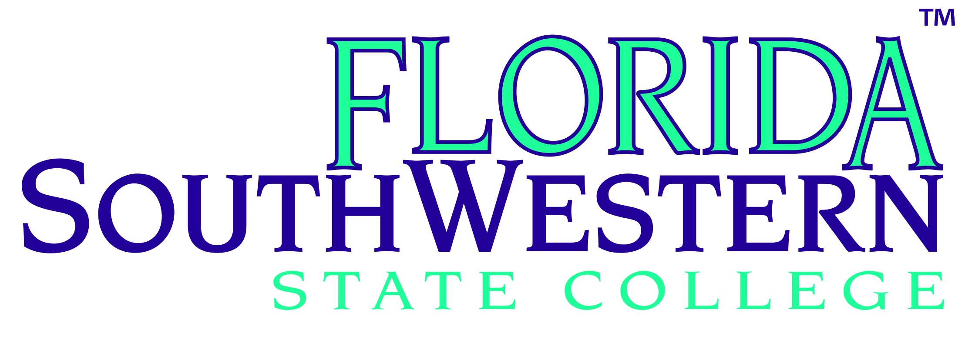

Florida SouthWestern State College District Board of Trustees

Business Affairs & Facilities Committee

Tuesday, August 26, 2014

1:15 – 2:45 p.m.

Collier Campus Room M-210

*Agenda*

Committee Members:Braxton C. Rhone; Sankey “Eddie” Webb, III; Byron Donalds; Gina Doeble.

Note: Braxton C. Rhone – planned absence for this meeting

|  |  |  |  |  |  |
| --- | --- | --- | --- | --- | --- |
|  | **Item** | **Enclosure** | **Discussion Leader** | **Presentation**  **Date for BOT Action** | **Proposed**  **Board Member addressing BOT on this item** |
|  | Investment Policy Review/Report | Attachment #1 p. 1-27 | Scott Stitcher, PFM Asset Management, LLC |  |  |
| 1. | Approval of Minutes  April 22, 2014 | Attachment #2 p. 1-3 | Gina Doeble |  |  |
| 2. | RFQ 14-03 – Continuing Contract for Construction Management Firms | Attachment #3 p. 1 - 1 | Steve Nice / Lisa Tudor | Sept. 23, 2014 | B. Donalds |
| 3. | RFQ 14-04 – Continuing Contract for Architectural Firms | Attachment #4 p. 1-1 | Steve Nice / Lisa Tudor | Sept. 23, 2014 | B. Donalds |
| 4. | RFQ-14-05 Architectural Services for Design Development of the Ren/Rem of Building “H”, Leonhardt Hall, Lee | Attachment #5 p. 1-1 | Steve Nice / Lisa Tudor | Sept. 23, 2014 | B. Donalds |
| 5. | Amended 2012/13-2017/18 Facilities Master Plan | See BOT Agenda Item #4 | Steve Nice | August 26, 2014 | B. Donalds |
| 6. | Foundation Audited Financial Report for FY ended March 31, 2013 | See BOT Agenda Item #5 | Gina Doeble / Deb Kivel | August 26, 2014 | E. Webb |
| 7. | Foundation Audit Review Checklist | See BOT Agenda Item #6 | Gina Doeble / Deb Kivel | August 26, 2014 | E. Webb |
|  |  |  |  |  |  |
| 8. | Foundation, Inc. Certificate of Compliance | See BOT Agenda Item #7 | Gina Doeble / Deb Kivel | August 26, 2014 | E. Webb |
| 9. | Financing Corp. Audited Financial Report for FY ended March 31, 2014 | See BOT Agenda Item #8 | Gina Doeble / Deb Kivel | August 26, 2014 | E. Webb |
| 10. | Financing Corp. Audit Review Checklist | See BOT Agenda Item #9 | Gina Doeble / Deb Kivel | August 26, 2014 | E. Webb |
| 11. | Financing Corp. Certificate of Compliance | See BOT Agenda Item #10 | Gina Doeble / Deb Kivel | August 26, 2014 | E. Webb |
| 12. | Approve Personnel *Consent* Item | See BOT Agenda Item #11 | Gina Doeble | August 26, 2014 | B. Donalds |
| 13. | Foundation Submission of Federal IRS Application for Recognition of Exemption Form 1023 & Federal IRS Return of Organization Exemption from Income Tax Form 990 (Information Only) | See BOT Agenda Item #12 | Gina Doeble / Deb Kivel | August 26, 2014 | E. Webb |
| 14. | Foundation 1st Qtr. Financial Statements & Investment Report (Information Only) | See BOT Agenda Item #13 | Gina Doeble / Deb Kivel | August 26, 2014 | E. Webb |
| 15. | Financing Corp. Submission of Federal IRS Application for Recognition of Exemption Form 1023 & Federal IRS Return of Organization Exemption from Income Tax Form 990 (Information Item) | See BOT Agenda Item #14 | Gina Doeble / Deb Kivel | August 26, 2014 | E. Webb |
| 16. | Financing Corp. 1st Qtr. Financial Statements & Investment Report (Information Item) | See BOT Agenda Item #15 | Gina Doeble / Deb Kivel | August 26, 2014 | E. Webb |
| 17. | College Monthly Financial Report  (Information Item) | See BOT Agenda Item #16 | Toby Discenza | August 26, 2014 | E. Webb |
| 18. | Collegiate High Schools Monthly Financial Report(Information Item) | See BOT Agenda Item #17 | Toby Discenza | August 26, 2014 | E. Webb |
|  | Meeting Adjourned |  |  |  |  |